Kigeme TVET School
Tel. +(250) 788673244
uwizefort@gmail.com
______________________
KIGEME TVET SCHOOL NARRATIVE REPORT ENDING 2019

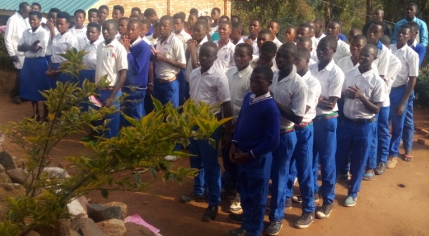
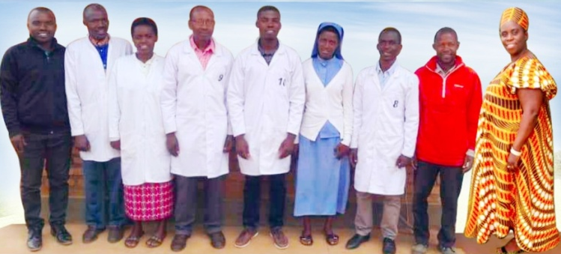
Kigeme TVET School Staff Kigeme TVET School students 2019
Kigeme TVET (Technical Vocational Educational Training) School in EAR Kigeme Diocese aims at helping children from poor family beneficiaries by helping them to get access to Technical Vocational Educational training to acquire knowledge and skills from different trades. This in turn to help them create their own jobs when they finish their trainings and will be able to struggle for life in different many ways and mainly change their life standards. Kigeme TVET School accommodates 81 students (42 boys and 39 girls) who are being educated by 5 teachers, 1 Secretary Accountant, 1 supporting staff and a School Manager.

Masonry students with the teachers delivering knowledge in this class.
Tailoring students with the teachers delivering knowledge in this class.
Carpentry students with the teachers delivering knowledge in this class.
Most of these students come from very poor families unable to pay school fees and find them consumables. The school always struggles to cover those expenses and we thank God that sometimes we find partners who help us in one way or another. The same way we are very proud to take this opportunity again to thank you for your heart of kindness and let you know that in the help of your donation we were able to purchase different consumables and materials enabling them to study practically in Masonry, Carpentry and Tailoring and help them to acquire skills and knowledge as strong weapon to prepare their future for a sustainable development and self -reliance.
Here below are the pictures showing different practices conducted by students in 3 trades and the finished products read to be used or sold. Surprisingly, in about eight months studying the students are able perform well the tasks assigned to them by their trainers:
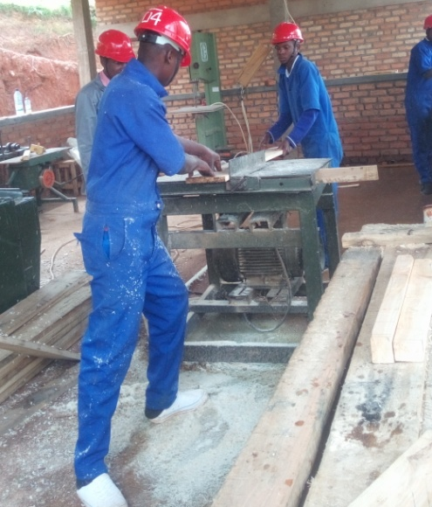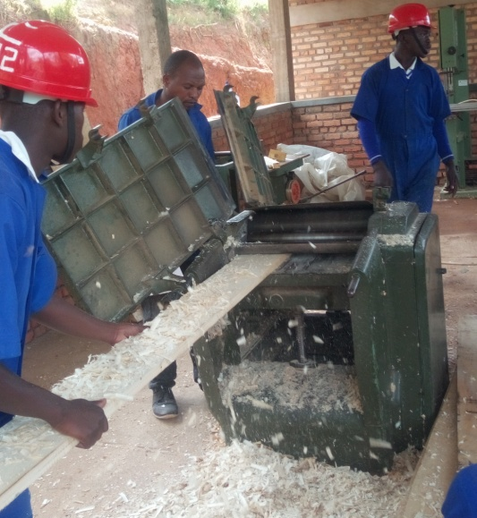
Carpentry students in Workshop are using Circular Saw machine and Saw Guide machines to prepare the materials to use in making furniture.

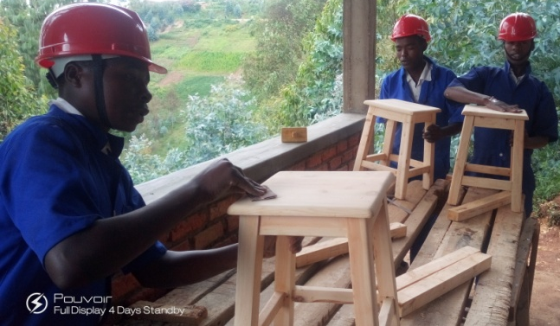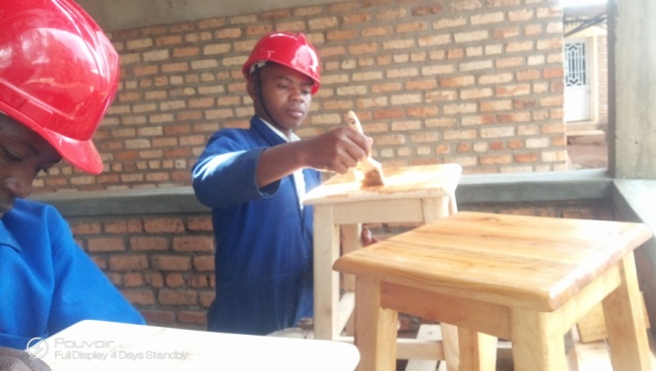
Carpentry students are in workshop finishing the tablets.
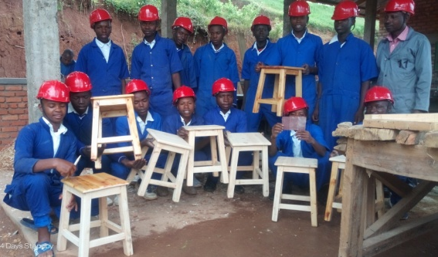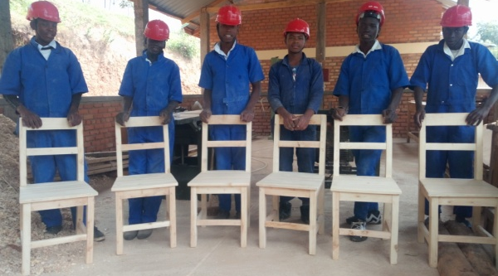
Carpentry students are very proud to have very good finished products from their courses.
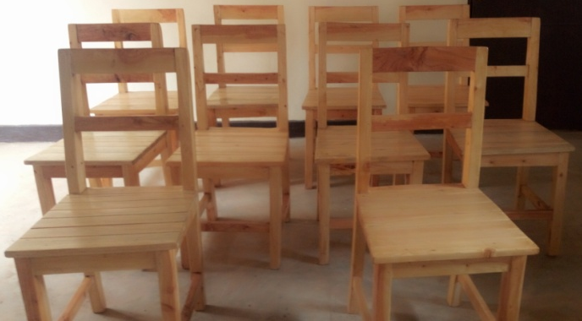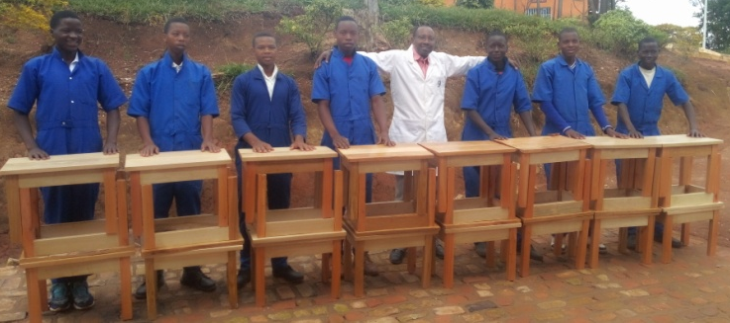
Carpentry students and their Trainer are proud of finished chairs and small tables.
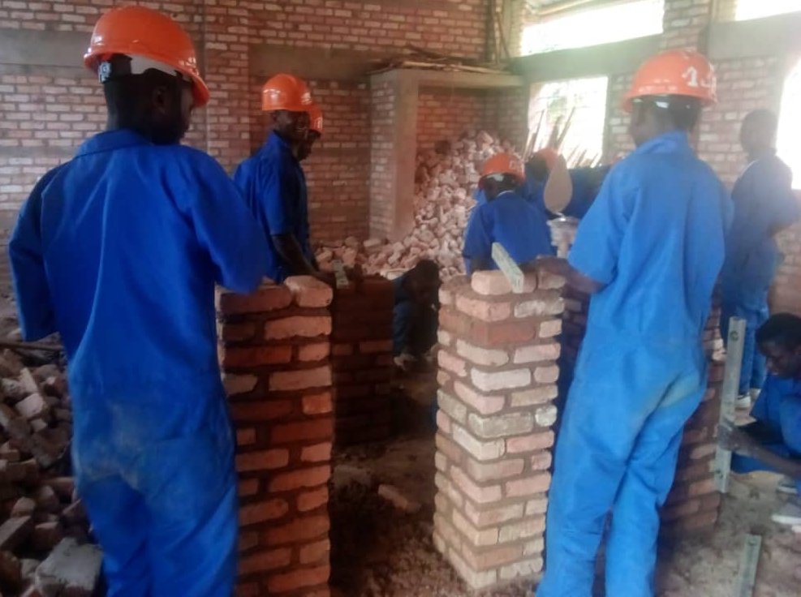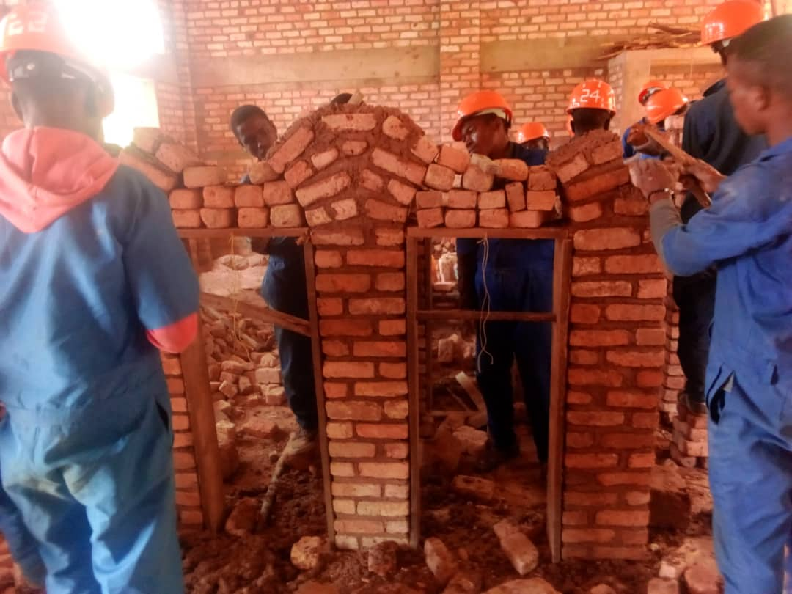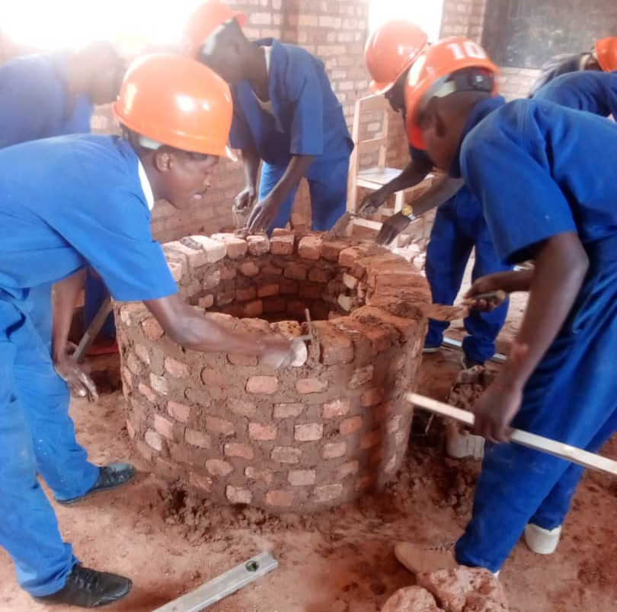
Masonry students are building columns, Arch and water tank.

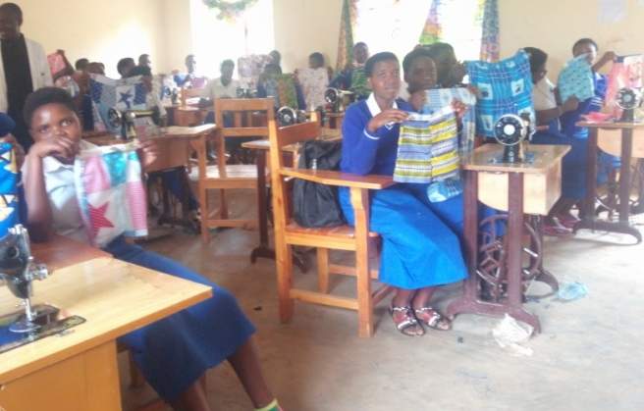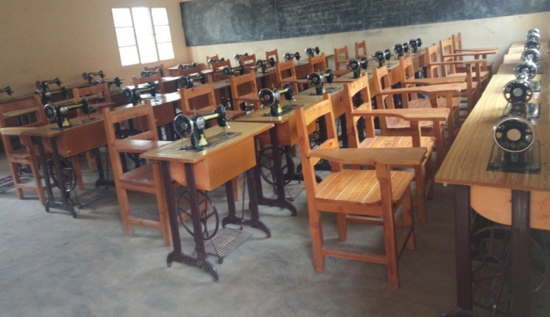
Tailoring students are in practice of sewing skirts for children. Here is Tailoring workshop.
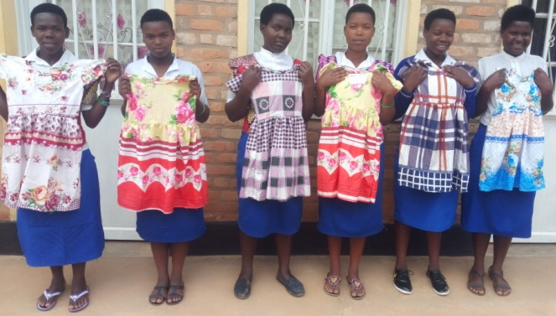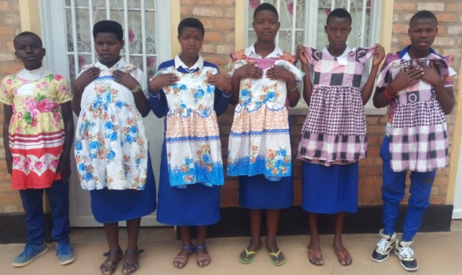
Tailoring students are showing the children dresses they have sewed.
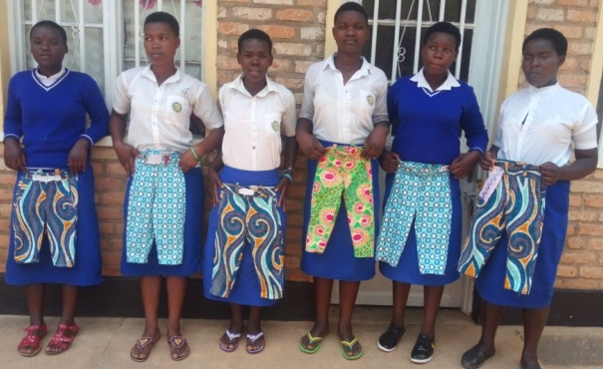
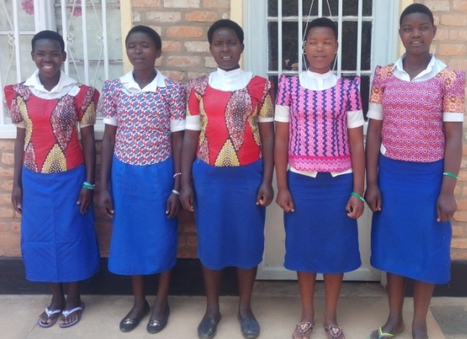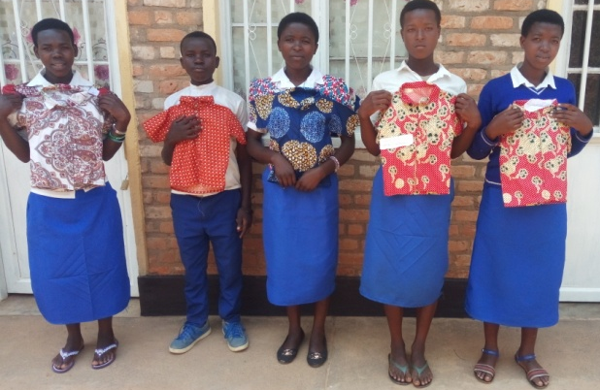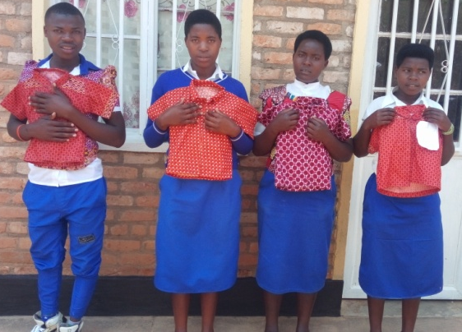
Tailoring students are very proud of fabrics, children trousers and shirts they have sewed.
Kigeme TVET School is very grateful to you and your friend in German for the support you provided to the school which was very helpful in finding consumables used by students especially the very poor ones in sewing different clothes, building and making furniture. The students are very happy that they have been enabled to acquire knowledge and skills as strong weapons to become smart youth who will develop themselves and create their own employment when they finish school and become self-reliant.
Done at Kigeme, on 20th October 2019

UWIZEYIMANA Fortunée
Kigeme TVET S. School Manager

